Introduction:
- What are short rows in knitting
  - Short rows is a technique in knitting a row that is partially knitted, turned and knitted back and forth for several rows to provide extra lengthening of the fabric to create shape or design.
- When is short rows useful when knitting
  - Short rows is used to create additional shape, depth, ease, and design interest in a pattern.
- Where do you use short rows - examples
  - Shaping the back of the garment across the shoulders
  - Shaping the cap of the sleeve
  - In bust darts
  - Shawl shapes
- What are the types of short row methods a knitter can use in knitting
  - Wrap and Turn (w&t)
  - German
  - Japanese
  - Yarn Over (not covered)
  - Catch Method (not covered)
- Examples of Short Row patterns:
  - The Doodler – Stephen West
  - Snood Barcelona – Svetlana Gordon
  - Short Row Sampler – Ann Weaver

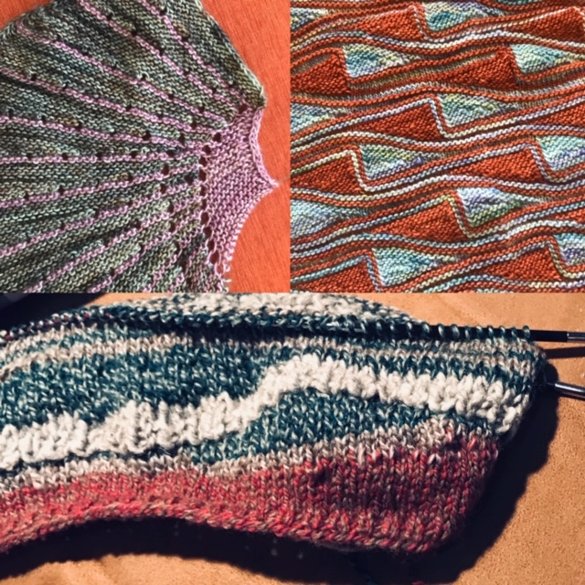

- References
  - Interweave Short Row Knitting – The Ultimate Guide: https://www.interweave.com/article/knitting/free-guide-knitting-short-rows/
  - Knitting Short Rows: Techniques for Great Shapes & Angles – Jennifer Dassau
  - Short Row Knits: A Master Workshop with 20 Learn-as-You-Knit Projects – Carol Feller

